Content 8

Constants, Manipulators And Operator Precedence

In this C++ tutorial, the topics which we are going to cover today are given below:

* **Constants in C++**
* **Manipulator in C++**
* **Operator Precedence in C++**

#### Constants in C++

Constants are unchangeable; when a constant variable is initialized in a program, its value cannot be changed afterwards.

**Code:**

1. #include <iostream>
2. using namespace std;
3. int main(int argc, char const *argv[])
4. {
5. const int a = 17;
6. cout << "The value of a is: " << a << endl;
7. a = 74;         //it is constant above so would not be cahnged in any conditiom.
8. cout << "The value of a is: " << a << endl;
9. return 0;
10. }

This program will throw an error because I had changed the constant at line 7.

#### Manipulator

In C++ programming, language manipulators are used in the formatting of output. The two most commonly used manipulators are: "**endl"** and "**setw"**.

* "**endl"** is used for the next line.
* "**setw"** is used to specify the width of the output and function present in iomanip file.

**Code:**

// *********** Manipulators ****************

#include <iostream>

#include<iomanip>   //using setw function of this library

using namespace std;

int main(int argc, char const *argv[])

{

    int a = 17,  b = 4567, c = 789956;

    cout <<"The value of a without setw(manipulator): "<<a<<endl;

    cout <<"The value of b without setw(manipulator): "<<b<<endl;

    cout <<"The value of c without setw(manipulator): "<<c<<endl;

    cout <<"\n\nThe value of a with setw(manipulator): "<<setw(6)<<a<<endl; //my last digit was 6 so iwant to ressemble valus acc to that.

    cout <<"The value of b with setw(manipulator): "<<setw(6)<<b<<endl;

    cout <<"The value of c with setw(manipulator): "<<setw(6)<<c<<endl;

     return 0;

}

**Output:**

The value of a without setw(manipulator): 17

The value of b without setw(manipulator): 4567

The value of c without setw(manipulator): 789956

The value of a with setw(manipulator): 17

The value of b with setw(manipulator): 4567

The value of c with setw(manipulator): 789956

#### Operator Precedence & Operator Associativity

**Operator precedence** helps us to solve an expression

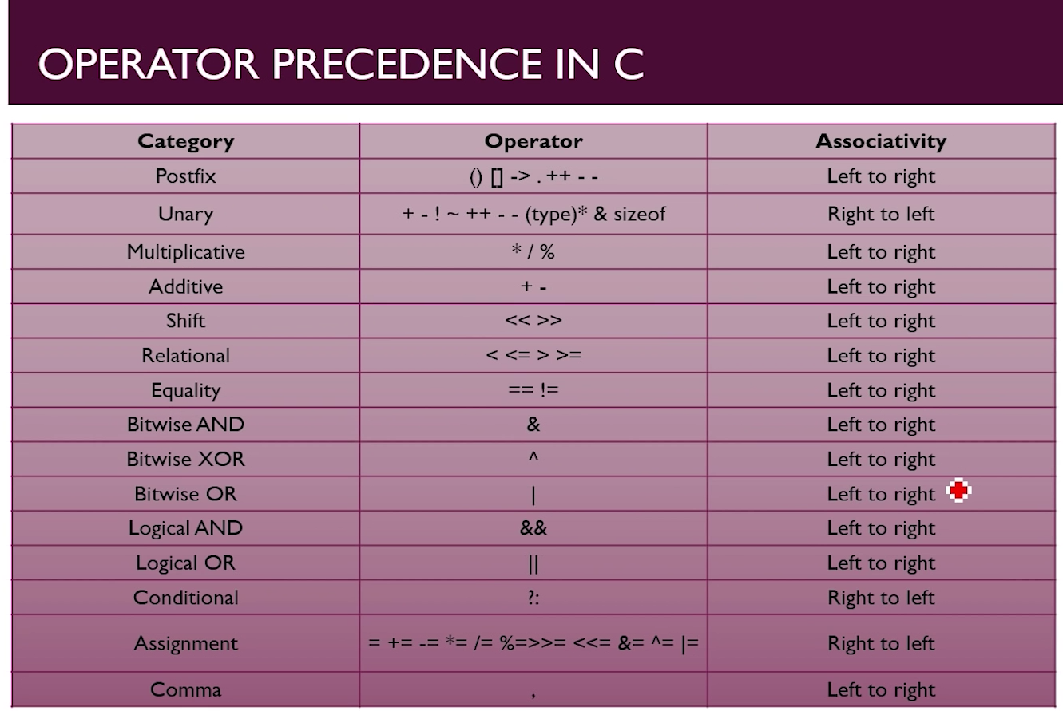

First we look for 2nd column and if operator occurs in same row then we go for associativity.